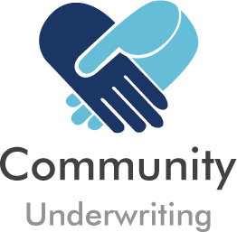
Insuring Not for Profits - it’s all we do

NSW SMALL BUSINESS STAMP DUTY EXEMPTION

DECLARATION

From 1 January 2018, Small Businesses (as defined by the NSW Office of State Revenue) will be exempt from paying NSW stamp duty on the following types of insurance offered by Community Underwriting:

- Professional indemnity insurance - covering liability arising out of the provision of professional services (other than medical indemnity cover).
- Product and public liability insurance - insurance covering liability for personal injury or property damage occurring in connection with, or arising out of the products or services of, a business.
- Commercial vehicle insurance - for a motor vehicle used primarily for business purposes’

What is a small business?
You are a small business if:

- You are an individual, partnership, company or trust that is an entity within the meaning of of section 152-10 (1AA) of the Income Tax Assessment Act 1997 of the Commonwealth for the income year in which the insurance is effected or renewed and:
- Are carrying on a business; and
- The business has an aggregated turnover of less than $2 million (Aggregated turnover is your annual turnover plus the annual turnovers of any business entities that are your affiliates or are connected with you.)

The NSW Office of State Revenue website states that the small business exemption does not apply for insurances:

- of an Association; or
- taken out by or on behalf of a non-profit organisation having as one of its objects a charitable, benevolent, philanthropic or patriotic purpose.

If you are a Not for Profit organisation, you should consider whether you are eligible to apply for a broader stamp duty exemption in NSW which applies to all classes of insurance.

Section 259 of the Duties Act 1997 provides that duty is not chargeable on certain transactions relating to charitable or benevolent bodies. Under this exemption stamp duty does not apply to any insurance taken out by or on behalf of a non-profit organisation having as one of its objects a charitable, benevolent, philanthropic or patriotic purpose.

More details and applications can be found on the Revenue NSW website.

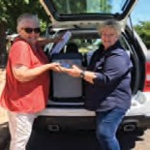

How do I apply for an exemption?
If you are not eligible for the broader exemption but fit the criteria of a small business, then you can complete this declaration.

A new declaration is required at each renewal period to satisfy legislative requirements.

Declaration

I declare that I am a small business eligible for the exemption from the requirement to pay duty on certain types of insurance under section 259B of the Duties Act 1997 (NSW).

Signed for and on behalf of the Insured:

Organisation Name:

Signatory Name:

Position:

Date:

