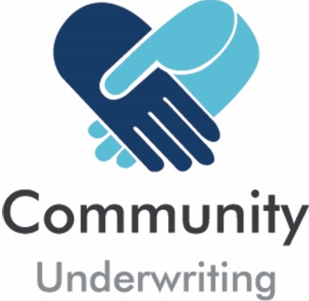

Medical and Allied Health Services Questionnaire
(Supplementary to the Insurance Quotation Request)

If we are providing coverage for medical professionals or other allied health services, we need additional information to consider your insurance quotation request:

Allied Health or Medical Services
Please detail the services being provided by the organisation:

Allied Health or Medical Personnel
If yes, please state the number of people engaged in the following categories:
Healthcare Professionals: | Full time employees | Part time & casual employees | Contractors | Separately Insured
Acupuncturists, Chinese medicine practitioners, chiropractors, osteopaths, physiotherapists, podiatrists
Nurses
Psychologists
Dietitians, nutritionists, occupational therapists, speech pathologists
Audiologists, pharmacists
Paramedics and midwives
Other (provide details):
Medical Professionals:
General practitioners
Surgeons, cardiologists, obstetricians, anaesthesiologists
Medical radiation practitioners, pathologists
Dental practitioners, optometrists, psychiatrists
Paramedics and midwives

Labour Hire / Contractors / Subcontractors

Please return this completed questionnaire with your Insurance Quotation Request.

Community Underwriting Agency Pty Ltd - AFS License No 448274 (Community Underwriting) acts under a binding authority as Agent for Berkley Insurance Company trading as Berkley Insurance Australia (ABN 53 126 559 706) and (where General Liability limits are purchased in excess of $20m) Berkshire Hathaway Specialty Insurance Company (Inc. Nebraska, USA.) – Excess Liability, to issue, vary and cancel policies on their behalf. In all aspects of this Policy, Community Underwriting acts as an agent for the insurers and not for the insured.

