Motor Theft Claim Form

About Community Underwriting

Community Underwriting Agency Pty Ltd (Community Underwriting) acts under a binding authority as Agent for Mitsui Sumitomo Insurance Company Ltd (MSI) to issue, vary and cancel policies on MSI’s behalf. In all aspects of this Policy, Community Underwriting acts as an agent for MSI, the Insurer and not for the Insured.

About the Insurer

Mitsui Sumitomo Insurance Company Ltd (MSI) ABN 49 000 525 637 AFS License No. 240816 is part of the Tokyo listed MS & AD Insurance Group with a global network of offices across 42 countries and regions.

Privacy

We seek at all times to comply with the Privacy Act 1988 and the Australian Privacy Principles therein. If We disclose personal information to You for any reason You must also act in accordance with and comply with the terms of the Privacy Act and the Australian Privacy Principles.
Purpose for collection of information:
The information contained in this document and any other documents provided to Us will be dealt with in accordance with our respective Privacy Policies.
Disclosure of Information that you provide to us:

We will only use the information in accordance with the terms of the Privacy Policies. Without limiting the application of the Policy We may disclose personal information to other in- dividuals or organisations in connection with Your claim, in- cluding legal advisors, other parties, other lawyers, experts and witnesses, courts and tribunals and other organisations that need to be involved in the matter. By submitting Your notification and continuing to deal with Us You consent to Us and these parties collecting, using and disclosing personal and sensitive information about You for these purposes. By signing the claim form You are consenting to the above.

You warrant to us that where you provide us with personal information that you have collected from other individuals:

- that the information has been collected in accordance with the Privacy Act 1988.
- that We are authorised to receive that information from you and to use it for the purpose of providing legal claims management services and advice.
- You, and the person who provided You with the information, are aware and have complied with the Privacy Act 1988 and have notified the person about whom the personal information is collected of the collection use and disclosure of such information.

By executing the claim form You are indemnifying Us against any breach that arises directly or indirectly out of any act or omission of Your part which does not accord with the conduct required under the Privacy Act 1988.

Direct Marketing:

We do not disclose personal information that We collect to a third party for the purpose of allowing them to direct market their products and services unless You have given Us Your permission for Us to do this.

Cross Border:

We will share Your personal information with the Community Underwriting and the MS & AD Insurance Group of compa- nies. Our data containing Your information is stored in Our data centre using dedicated hardware and network. We may also use Saas, Cloud computing or other technologies from time to time and Your information may be stored outside Australia.

We will not transfer personal information to a recipient in a foreign country unless We have appropriate protections in place as required by the relevant privacy laws. Your informa- tion will be stored on Our data base for such period of time as required by law.

Community Underwriting Agency Pty Ltd - AFS License No 448274 (Community Underwriting) acts under a binding authority as Agent for Mitsui Sumitomo Insurance Company Ltd (MSI) ABN 49 000 525 637 AFS License No. 2401816 to issue, vary and cancel policies on Mitsui’s behalf. In all aspects of this Policy, Community Underwriting acts as an agent for the insurer and not for the insured.

Further information

If you would like further information, please review the full Privacy Policy at www.communityunderwriting.com. au and www.msi-oceania.com or if you have any complaints or con- cerns over the protection of the information you have given to us or that we have collected from others, contact:

Community Underwriting Agency Pty Ltd
P.O. Box 173, Balmain NSW 2041 Telephone 02 8045 2580

Mitsui Sumitomo Insurance Company Limited Level 18, 1 Bligh Street
Sydney, NSW 2000
Telephone 02 9222 7600

GST and Insurance Requirements

If you are registered for GST purposes and have an entitlement to claim an Input Tax Credit (ITC) for GST paid on your insurance, you are required to inform your insurer, at or before the time of any subsequent claim, of the extent to which you are eligible to claim an ITC.
The amount that we are liable to pay under this policy will be reduced by the amount of any ITC that you are or may be entitled to claim for the supply of goods or services covered by that payment.
If you are liable to pay an excess under this policy, the amount payable will be calculated after deduction of any ITC that you are or may be entitled to claim on payment of the excess.

Complaints
Any enquiry or complaint relating to this insurance should in the first instance be referred to:

Complaints Manager
Community Underwriting Agency Pty Ltd
P.O. Box 173, Balmain NSW 2041

If this does not resolve the matter or You are not satisfied with the way a complaint has been dealt with, You should contact:

Mitsui Sumitomo Insurance Company Limited Level 18, 1 Bligh Street
Community Underwriting are specialists in charity insurance, not for profit insurance and insurance for community organisations. We offer a range of insurance solutions customised to meet the needs of community organisations, including P&C Association insurances.
Contact us today!
Call us: 02 80452580
enquiries@communityunderwriting.com.au www.communityunderwriting.com.au

AFS No 448274 ABN: 60 166 234 715
Sydney, NSW 2000
Telephone 02 9222 7600
Facsimile 02 9232 7006

Section 1
Policy Information

Policy Number Expiry Date / /

Section 2
The Insured

Insured (association, company, corporation) Contact person: Telephone: Home Work Mobile Preferred method of contact

Section 3
GST

Are you registered for GST? No
Yes
What is your ABN?

Have you claimed or intend to claim an Input Tax Credit (ITC) on the
GST component of the premium applicable to the policy? No Yes Specify amount claimed %
Are you entitled to claim an ITC credit for repairs or
replacement of the item that has been lost of damaged? No Yes Specify amount claimed %

Section 4
Vehicle Details

Make of Vehicle Year Model Registered No. Colour Engine No. Registered Owner Odometer Reading
Address
State Postcode
Has the vehicle been modified from original specifications? No Yes
Provide details
Is the vehcile under finance?
No Yes

Name of Lender Account No.
Address
State Postcode
Section 5
Details of the Theft

Date Day Time am/pm From where was your vehicle taken?
Street Suburb

Why was your vehicle left there?

Community

Was the vehicle locked? Yes No Was a burglar alarm fitted: Yes No

Was any other protective device fitted? Yes No To which police station was the theft reported?
Was it activated: Yes No

Station Report No Officer Date

Details of any Recovery of the Vehicle
Section 6

Date recovered: Time Recovered:
Explain the circumstances of the recovery (e.g. who, how, where, towing company, current location):

Sketch Diagram
Shade in damage to vehicle

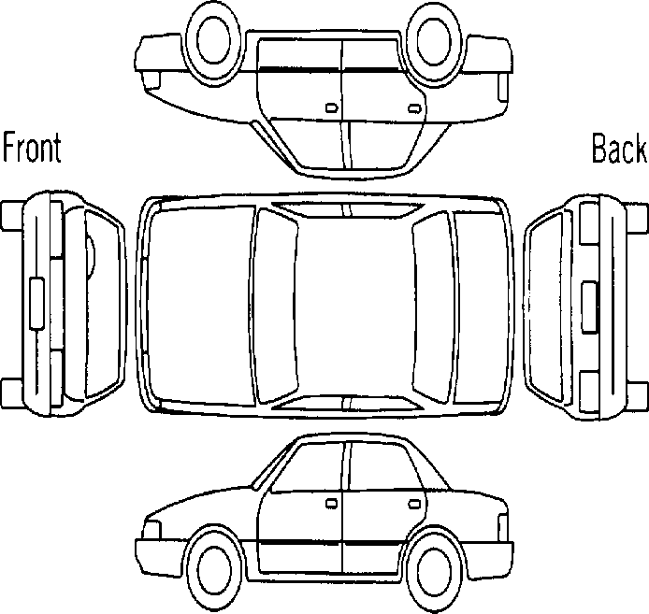

Details of any items stolen or damaged:
Item: Purchase Date: Purchase Price: Amount Claimed: Item: Purchase Date: Purchase Price: Amount Claimed: Item: Purchase Date: Purchase Price: Amount Claimed:

Section 7
Owner(s) and Driver History
In the last 5 years have you as owner or driver of this vehicle:
- Had an insurance refused, declined or cancelled by an insurer or any special conditions imposed? No Yes
- Been convicted or charged with:
  - drug use, driving under the influence, or exceeding Prescribed Concentration of Alcohol? No Yes
  - any driving offences or speeding? No Yes
  - fraud, arson, theft or any other criminal act? No Yes
- Had a drivers or motorcycle licence cancelled, suspended or endorsed? No Yes
- Had a claim or accident? (include any not reported or not claimed from an insurer) No Yes
- Had a car stolen or burnt out? (include any not reported or not claimed from an insurer) No Yes
- Suffered or suffer from impaired eyesight (excluding wearing of glasses), loss of or use of any limb or
loss of hearing or from any physical defect or epileptic, diabetic, heart or mental condition? No Yes
If you answered Yes to any of the above questions please provide relevant details below

Section 7
continued

Name of Driver | Date of Incident | Details of each Incident | Your Insurer | Person at Fault /Nature of Charge
If there is insufficient space, please attach a sheet with the relevant information.

Section 8
Direct Deposit

Should any part of this claim be payable to you please provide your bank account details for direct deposit purposes.
BSB A/C Number Bank
Name of Account

Section 9
Declaration

I declare that to the best of my knowledge and belief, the information in this form is true and correct and I understand the claim may be refused or reduced if information is withheld.
I understand that I may have to provide relevant documentation to enable complete consideration of my claim.
I consent to Community Underwriting, Mitsui Sumitomo and their agents using the personal information I have provided on this form for the purposes of processing my claim. Accordingly, I consent to Community Underwriting, Mitsui Sumitomo and their agents obtaining or disclosing my personal information as required with other insurers, insurance reference bureaus, credit reporting agencies, loss adjusters, investigators, lawyers or as required by law to do so.
I declare that I have read and understood the Privacy information and consent to the collection, storage, use and disclosure of personal and sensitive information of all persons covered by this Form. Where personal information has been provided on someone else’s behalf, that person has consented to this provision.
Driver’s Signature Date / / Signature of insured or person with authority for and on behalf of the association or company.
Signature Date / / Position Held

