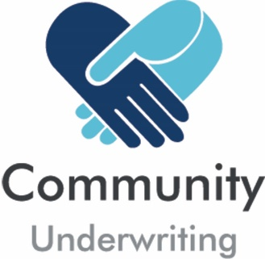

Camping Facilities Questionnaire
(Supplementary to the Insurance Quotation Request)

If your organisation organises, promotes or co-ordinates any camps, we require some additional details on the type of camp arrangements and activities to determine if we can provide cover under the Community Underwriting General Liability policy:

General Information
  - Where will the camp be held? What is the duration?
  - What is the camp agenda / main activities planned?

  - No of attendees at each camp Age range of attendees Ratio of Campers to Supervisors
- Is a risk assessment undertaken for the camp to identify hazards and potential exposures? | No | Yes
- Do all campers / parents of attending children sign permission and waiver documentation? | No | Yes
- Are written instructions from parents required prior to administering medication to minors? | No | Yes

Camps at third party commercially operated venues
- The third-party organisation provides accommodation, organises and is responsible for all camp activities (and is separately insured for this) | No | Yes

Camps at third party venues or in camp sites approved by a State or National Park Authority
- What activities will be undertaken by you?

- What activities will be provided by the camp operator / outsourced to third party providers (and separately insured)?

- Who will be responsible for assessing and monitoring the competency / ability of participants in any physical activities including waterborne, ropes and use of equipment?

- Are animals on the camp site? No Yes If Yes - how are they separated from the campers?

Camps in open bushland (We are unable to provide cover for these activities)

Please return this completed questionnaire with your Insurance Quotation Request.

Community Underwriting Agency Pty Ltd - AFS License No 448274 (Community Underwriting) acts under a binding authority as Agent for Berkley Insurance Company trading as Berkley Insurance Australia (ABN 53 126 559 706) to issue, vary and cancel policies on Berkley’s behalf. In all aspects of this Policy, Community Underwriting acts as an agent for the insurer and not for the insured

Community Underwriting Alcohol Questionnaire 0319 1/1

