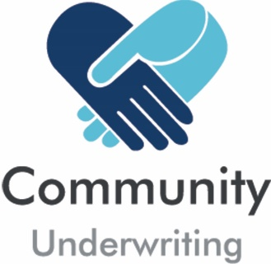

Alcohol Questionnaire
(Supplementary to the Insurance Quotation Request)

Where alcohol will be served, we require some additional details to determine if we can provide cover under the Community Underwriting General Liability policy:

- Function held on third party commercially licensed premises
- The third-party organisation holds a liquor license? | No | Yes
- The third-party is responsible for all aspects of the supply of alcohol including responsible service of alcohol, under aged attendees and alcohol impaired attendees? | No | Yes

- Private function where you will be serving, supplying or selling alcohol to invited guests:
- Will you obtain a liquor license? | No | Yes
- Has any liquor license ever been suspended or revoked? If Yes, why? | No | Yes
- Are under aged people invited to the event? If yes how will they be confined and/or distinguished from people over 18 years of age? | No | Yes
- Are volunteers / staff / contractors trained in the responsible service of alcohol? | No | Yes

- Open event where you will be serving, supplying or selling alcohol to attendees:
- Will you obtain a liquor license? | No | Yes
- Has any liquor license ever been suspended or revoked? If Yes, why? | No | Yes
- Are attendees allowed to bring alcohol to the event? | No | Yes
- Are under aged people invited to the event? If yes how will they be confined and/or distinguished from people over 18 years of age? | No | Yes
- Are volunteers / staff / contractors trained in the responsible service of alcohol? | No | Yes
- How will alcohol impaired attendees be managed? | No | Yes

Please return this completed questionnaire with your Insurance Quotation Request.

Community Underwriting Agency Pty Ltd - AFS License No 448274 (Community Underwriting) acts under a binding authority as Agent for Berkley Insurance Company trading as Berkley Insurance Australia (ABN 53 126 559 706) to issue, vary and cancel policies on Berkley’s behalf. In all aspects of this Policy, Community Underwriting acts as an agent for the insurer and not for the insured.
Community Underwriting Alcohol Questionnaire 0319 1/1

