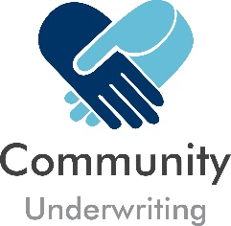
- Please complete all sections of the declaration
- If the Quotation or Policy number is not known to you, please contact your insurance broker or agent to obtain these details

Your Details

- Name(s)

- Policy (Quotation) Number

Declaration

- I/We hereby declare that as of today’s date I/we have no outstanding claims and after enquiry there are no circumstances or events which may potentially give rise to a claim.
- I/We also hereby declare that there have been no changes to matters disclosed in the proposal form previously supplied to Community Underwriting Agency.

Date Original Proposal Completed

/ /

Authorised Signature

Date
/ /

