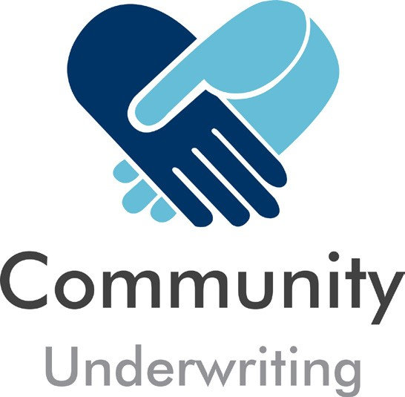

2020 SMALL GRANTS
PROGRAM
APPLICATION FORM
Reinvesting your insurance dollars back into the sector

1. APPLICANT INFORMATION

1.1 Organisation name

1.2 Project name

1.3 Policy Number ______

1.4 Amount of grant you are applying for:

$5,000 $2,000 $1,000 Other Smaller Discretionary Amount _

Other sources of income anticipated for this project ___

Total expected project cost

1.5 Have you received funding from Community Underwriting in the past Yes No

If yes please name the project / year / amount

1.6 Person responsible for the project

Name

Position |  | Email
Phone |  | Mobile

Address

Insuring Not for Profits - It ’s All We Do

2. PROJECT INFORMATION

2.1 Project summary

2.2 Project location

2.3 Project need (What is the specific need targeted by your project)

2.4 Project timeline, milestone and completion date

2.5 Project impact / results (What will be achieved and what / who will be impacted or benefited by the project or initiative)

Insuring Not for Profits - It ’s All We Do

3. ADDITIONAL SUPPORTING INFORMATION

By signing and submitting this application you acknowledge:

• That you are authorised by your organisation to make this application on its behalf and declare that all of the information provided is true and correct;
• You have read the Community Underwriting - 2020 Small Grants Program Funding Guidelines and agree to those terms and conditions.

Name
Signature

Date
Policy No

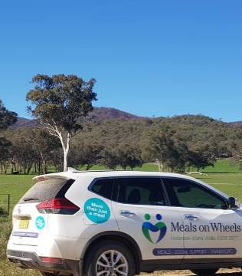
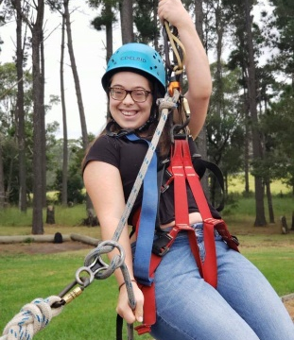

Community Underwriting are specialists in charity insurance, not for profit insurance and insurance for community organisations. We offer a range of insurance solutions customised to meet the needs of community organisations, including P&C Association insurances. Contact us today!
Call us: 02 80452580 Email us: enquiries@communityunderwriting.com.au www.communityunderwriting.com.au
AFS No 448274 ABN: 60 166 234 715

